Dataflow can run in networks that are either in the same project or in a separate project which we call the host project.

When a network exists in a host project, we call the networking setup VPC.

Shared VPC lets organization admins delegate administrative responsibilities, such as creating and managing instances, to others while maintaining centralized control over network resources like **subnets, routes, and firewalls.**

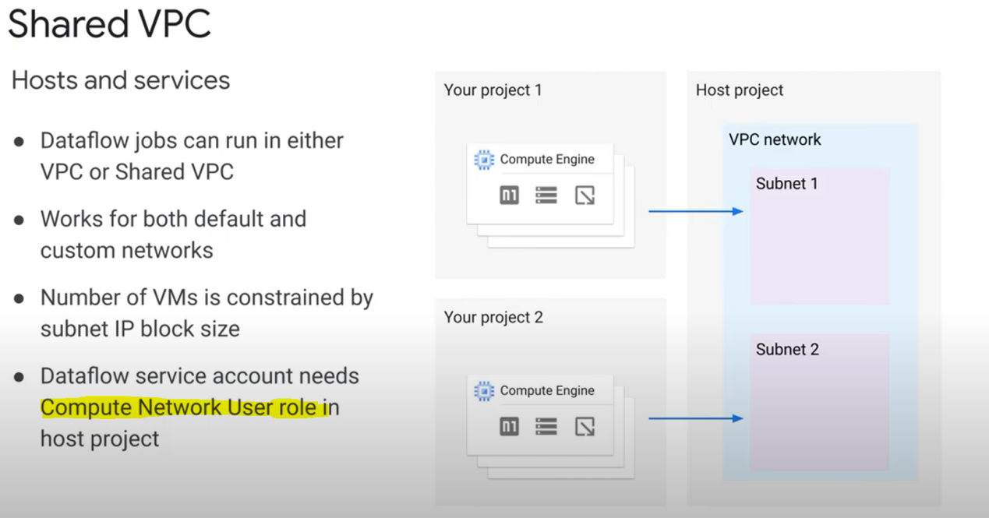

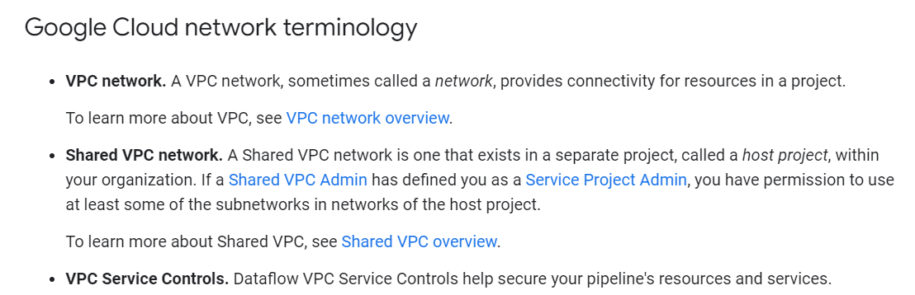

A custom network is one where you create the network and define the regions and the subnets in the network. When setting the number of workers to use, remember to have enough IP addresses available.

For example, if you have a subnet with a /29 subnet and no other VMs running in it, the maximum number of Dataflow workers that you can launch is four.

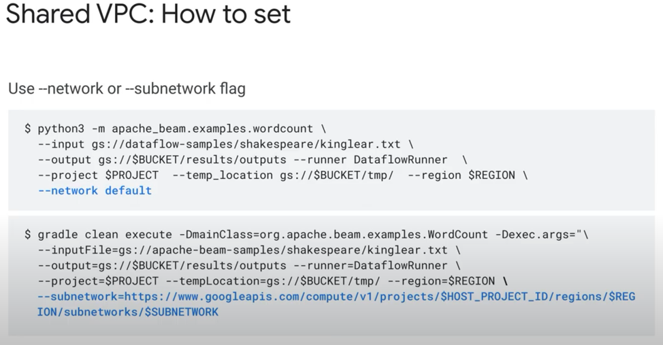

Private IPs:

You can block external IPs (/public IPs)

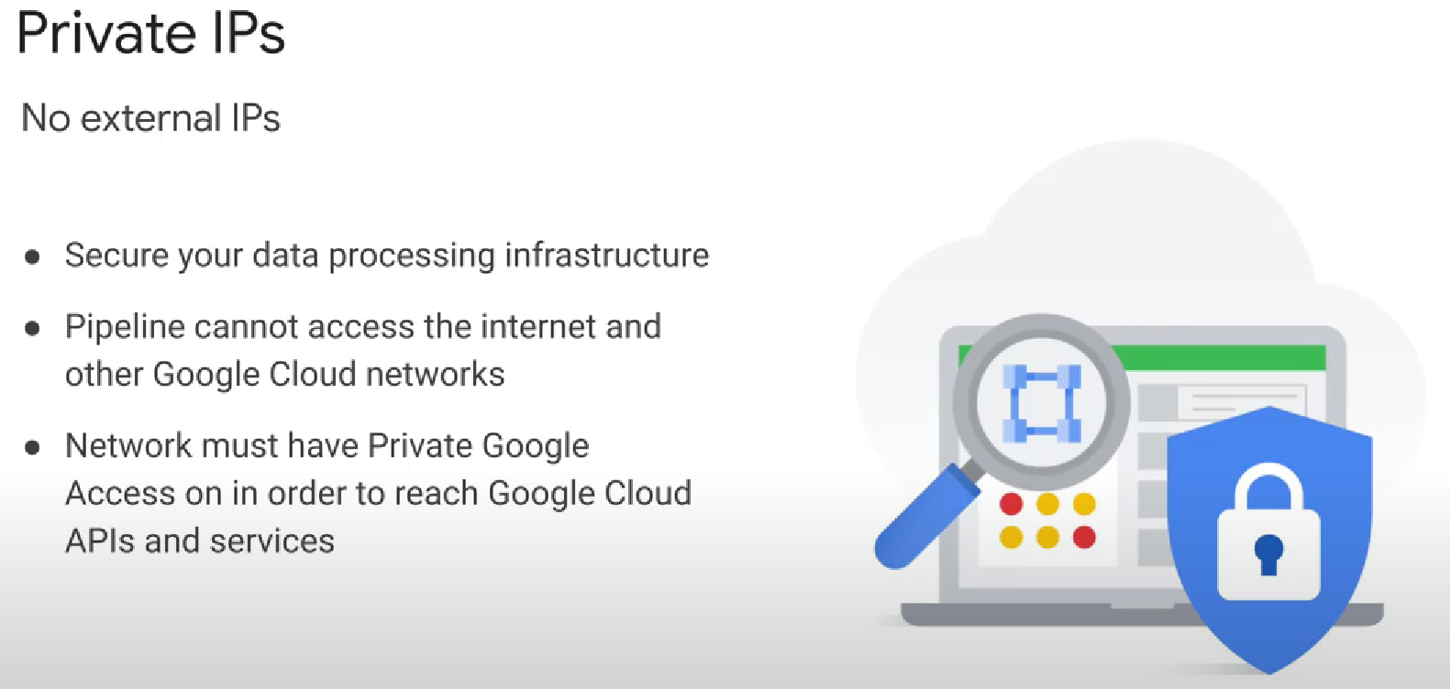

By not using public IP addresses for your Dataflow workers, this will lower the number of public IP addresses you consume against your in-use IP address quota.

When you turn off public IP addresses, the Dataflow pipeline can access resources only in the following places: another instance in the **same VPC network, a shared VPC network**, or **a network with VPC network peering enabled.**

If your pipeline is communicating with other Google services and APIs and is in a custom network, **Private Google Access must be enabled** for the subnetwork your worker will be launched in. And to enable it, you need to have the «role=roles/**compute.networkAdmin**» role.

Code:

The first flag to specify is either the network or subnetwork the workers should run in. The second flag, no_use_public_ips, lets Dataflow know that you want to launch the workers with internal IP addresses only.

